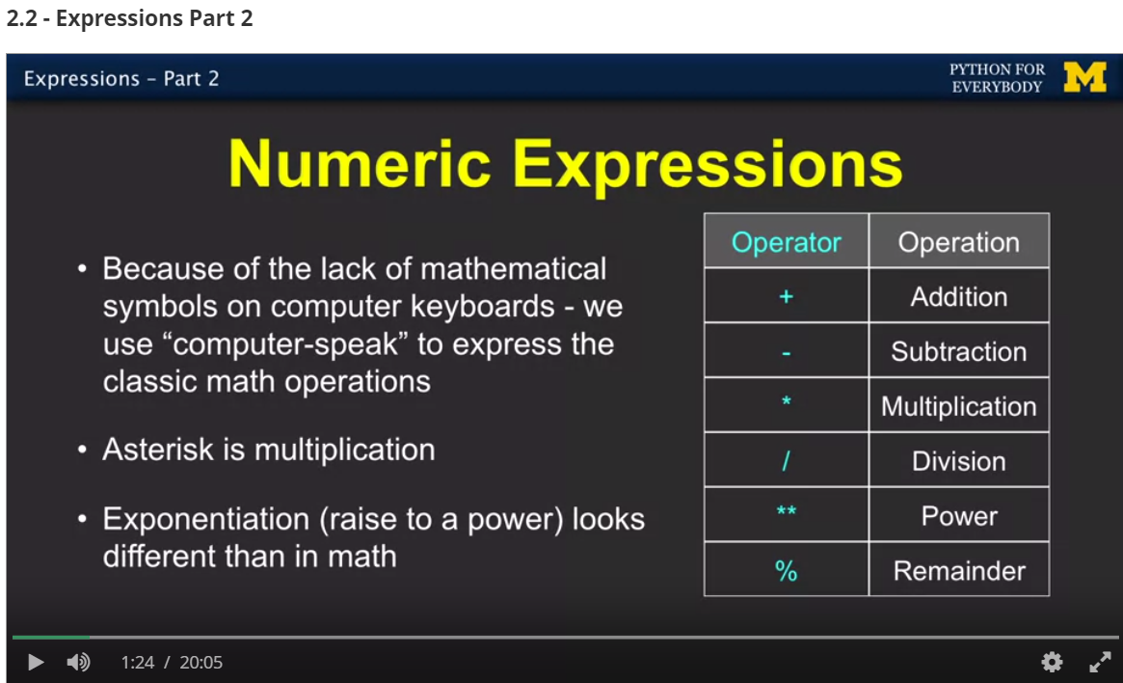

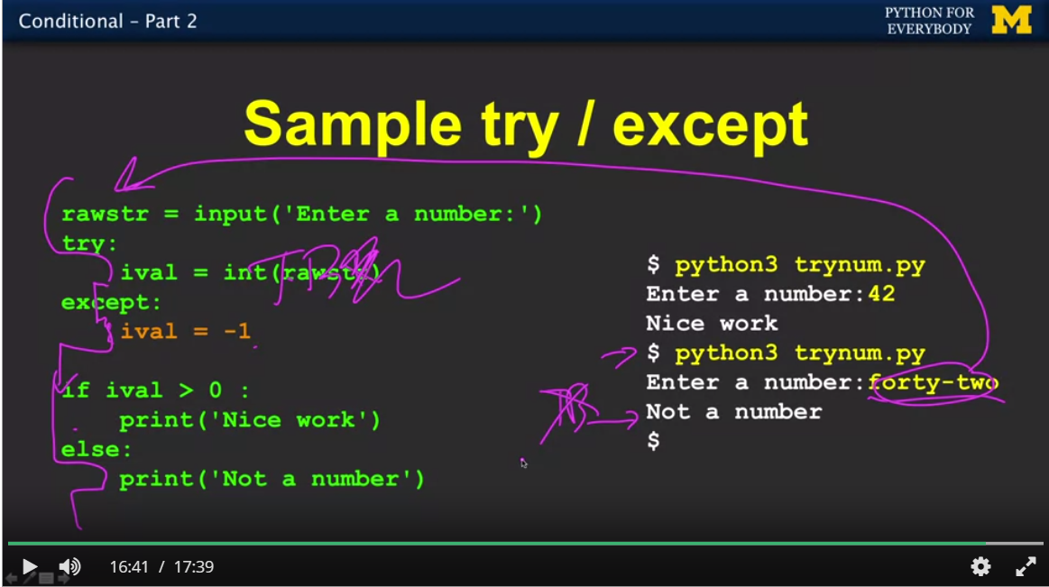

Quit()

‘is’ is stronger than ‘==’ (both type and value)

If smallest is None

…because the two pieces, algorithms, control flow and data structures are the two pieces of programming that give you the whole picture.